Ibraheem

42896

BSCS 5

**Project phase 3**

**Task 3.1**

In this phase, you have to perform paging. For this purpose, you have to allocate memory to a process and according to that memory requirement you have to create pages for that process. The page size should be read from a file containing information about page size. This page size can be set from configuration menu.

Screenshot :

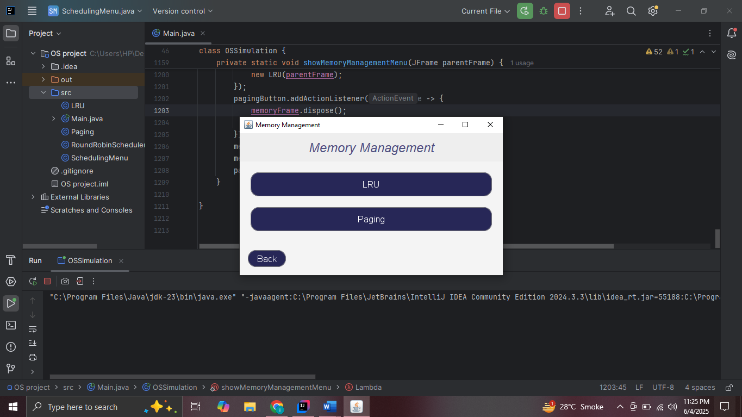

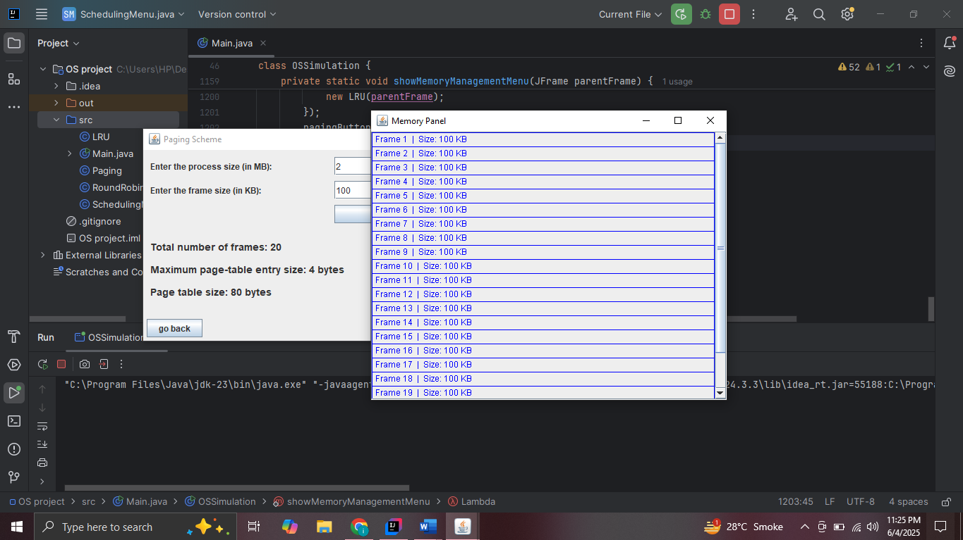

**Task 3.2**

You have to also employ page replacement algorithm. Implement the LRU page replacement algorithm

Screenshot :

